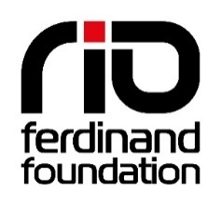
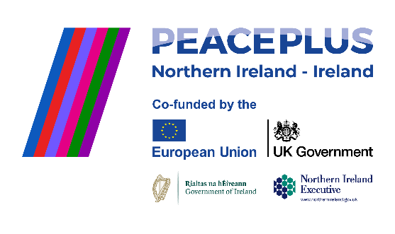


JOB DESCRIPTION

POST DETAILS
Post Title: Programme Coordinator (Sligo)
Location: Sligo
Salary: €32,200 pro rata
Hours: Part-time, 25 Hours per week

JOB SUMMARY:
As a partnership with the Rio Ferdinand Foundation, Sligo Rovers FC are recruiting a regional Programme Coordinator to coordinate and deliver a PEACE Academy programme supporting young people in Sligo and Belfast, supported by PEACEPLUS, a programme managed by the Special EU Programmes Body (SEUPB) https://www.seupb.eu/
The aim of this new three-year programme, is to deliver and evidence a PEACE Academy pathway of engagement, learning, social action and employability that will inspire young people from communities in Northern Ireland and Ireland to create shared experiences and build a long-term response to sectarianism, racism and hate on a cross community and cross border basis.
Line Managed by the Rio Ferdinand Foundation PEACE Academy Programme Manager, the role will be directly employed by Sligo Rovers FC coordinating programme delivery in and across the Sligo region, working alongside a Programme Coordinator employed by Glentoran FC in Belfast. They will work closely with a PEACE Academy team within their communities as well as on a cross-border basis.
KEY DUTIES/RESPONSIBILITIES:
This role will:
- Deliver and develop the Rio Ferdinand Foundation’s new PEACE Academy Programme in partnership with Glentoran FC and Sligo Rovers FC together with a network of grass-root partners, as well as community policing and other strategic stakeholders.
- Line manage a team of sessional staff in your region and work closely with your cross-border counterpart as well as the programme’s Training Lead, Monitoring Officer, Admin Officer and Finance Officer.
- Deliver an inclusive three-year cross border and cross community youth and community development programme engaging young people from Catholic / Nationalist / Republican (CNR), Protestant/ Unionist/ Loyalist (PUL) marginalised and newcomer communities.
- Development and delivery of our youth development pathway across your region and on a collaborative cross-border basis, including twice weekly activity and mentoring sessions, which utilise youth culture as a platform for personal development, working with your staff team to design, deliver and manage engaging sessions and opportunities utilising music and the creative arts, sport, and digital media.
- Work with our Training Officer to plan and deliver workshops, seminars and accredited training for young people in your region as well as on a collaborative cross-border basis.
- Devise and deliver a range of community events in your region as well as cross-border events and initiatives, careers events and pathways with a range of commercial partners and strategic stakeholders.
- Support young people to develop their own youth social action projects tackling sectarianism, racism and hate on a cross community and cross border basis.
- Encourage and support the involvement and development of volunteers from the local community.
- Reporting to your line manager, the Rio Ferdinand Foundation PEACE Academy Programme Manager on a regular basis against key miletones and targets
- Working closely with the wider Sligo FC community teams to ensure the PEACE Academy is embedded within their wider work and networks
- Develop positive relationships with all partners involved in the project and ensure links are made and information shared with appropriate agencies.
- Work closely with our PEACE Academy Programme Manager on the strategic positioning and development of the Foundation and the legacy of the PEACE Academy programme.
- Be responsible for the delivery of specified targets for the programme in your region through contributing to and following action plans and work programmes.
- Work with our Monitoring Officer to ensure all monitoring data is captured and recorded against targets ensuring funder reports are produced and meetings attended as and when required.
- Work with our Finance and Admin Officers to ensure all administrative and financial functions of the programme are conducted in accordance with funder requirements
- Work with an external monitoring agency to ensure their independent impact evaluation is completed alongside our own internal monitoring.
- Work with our Director of Development on implementing a communications strategy for the PEACE Academy.
- Keep up to date with local and regional trends in sports/arts for social change and work with young people.
- Actively represent Rio Ferdinand Foundation at working groups, initiatives, and events.
- Assist and contribute to the on-going development of the Rio Ferdinand Foundation’s work in Sligo and Belfast as well as across the island of Ireland.
- Develop and maintain key relationships with partners from across various sectors including, statutory, private, business and third sectors.
The successful candidate will be required to complete an Enhanced DBS disclosure.
OTHER RESPONSIBILITIES
- Work flexibly where appropriate on evening, weekends and during school holidays to ensure full and supportive delivery of the programme.
- Undertake new training to develop work related skills and knowledge
- Undertake any other related responsibilities commensurate with the evolving objectives of the post and the evolution of the Foundation, as may reasonably be requested
- Work with due regard for RFF’s core values and objectives
- Ensure the effective implementation of, and adherence to RFF’s Equal Opportunities, Safeguarding and Health and Safety policies and procedures.

PERSON SPECIFICATION:
Qualifications, Experience, Knowledge & Skills
- Relevant academic/industry qualifications: e.g. Youth Work, Certificate in Community Sports Work (CCSW), Arts Practitioner, etc.
- Ideally educated to degree standard or equivalent through experience
- An appropriate qualification relevant to working with young people
- Sports, Arts or Digital Media qualification (desirable)
Experience
- Have at least three years’ experience of working with disaffected young people
- Have at least two years’ experience of coordinating large-scale projects across a specific region as well as on a collaborative cross-border basis.
- A proven track record of forming productive relationships with a wide variety of organisations and individuals from diverse backgrounds and multi-agency co-ordination
- Experience delivering community focused, social inclusion initiatives, ideally working with local authorities, police, sports clubs and youth justice groups
- Experience of working on a multi-partner project
- A good understanding of community engagement projects
- Experience of campaigns, youth social action programming and event management
- Experience of managing an SEUPB Programme or similar (desirable)
Knowledge
- A thorough understanding of government policies and plans for community sport and creative arts, along with relevant opportunities for young people’s development
- Understanding of the issues facing young people across the island of Ireland
- A working knowledge and understanding of the barriers to personal development in areas of deprivation

Skills
- Good numerical and analytical skills
- Ability to challenge young peoples’ attitudes and beliefs to promote their social and educational needs
- Supervision of sessional staff and volunteers
- Communication skills – to young people, families, project staff, local partners and community stakeholders as well as senior management
- Ability to work in a confident and flexible manner
- Ability to initiate, develop and sustain effective relationships with both young people and partners
- IT literate using MS Office (word, excel, power point, outlook)
- Coaching skills
- Clearly demonstrate an ability to build trusting relationships and deliver high quality activities for young people.
- Proactive, resilient, and able to work well within a close-knit team.
- Able to identify and share best practice in the community environment
- Self-starter, used to delivering targets on time to high standards
- Excellent problem solving and multi-tasking skills
- Confident user of social media platforms - Twitter, Insta, Facebook, Youtube – (desirable)

